PRELIMENERY REPORT ON

“Machine Learning based security system for office
premises"

SUBMITTED TO THE SAVITRIBAI PHULE UNIVERSITY, PUNE

IN THE PARTIAL FULFILLMENT OF THE REQUIREMENTS

FOR THE AWARD OF THE DEGREE

OF

BACHELOR OF ENGINEERING (COMPUTER ENGINEERING)

SUBMITTED BY

Mr. MEHUL INGALE | Exam No. 19
Miss. MEGHA PATIL | Exam No. 67
Mr. SIDDHARTH NILAKHE | Exam No. 51
Mr. E NAVANEET KUMAR | Exam No. 11


DEPARTMENT OF COMPUTER ENGINEERING

ALL INDIA SHRI SHIVAJI MEOMRIAL SOCIETY’S

INSTITUTE OF INFORMATION TECHNOLOGY

KENNEDY ROAD, NEAR R.T.O. PUNE-411001

SAVITRIBAI PULE PUNE UNIVERSITY

2020-2021



CERTIFICATE

This is to certify that the project report entitles

“Machine Learning based security system for office
premises "

Submitted by
Mr. MEHUL INGALE | Exam No. 19
Miss. MEGHA PATIL | Exam No. 67
Mr. SIDDHATH NILAKHE | Exam No. 51
Mr. E NAVANEET KUMAR | Exam No. 11

is a bona de student of this institute and the work has been carried out by him/her under the supervision of Mrs. Minal Nerkar and it is approved for the partial fulfillment of the requirement of Savitribai Phule Pune University, for the award of the degrees of Bachelor of Engineering (Computer Engineering).

(Mrs. Minal Nerkar)

Guide

Department of Computer Engineering

(Dr. S.N. Zaware)

Head

Department of Computer Engineering

(Dr. P.B. Mane)

Principal

AISSMS Institute of Information Technology, Pune-411001

Place: PUNE

Date:

ABSTRACT

Safety plays a major role in today’s world. User authentication, i.e., a procedure to verify the identity of the user, is essential in the digital world so as to protect the user’s personal data stored online (e.g. online bank accounts) and on personal devices (e.g., smart phones, laptops) and to also enable customized services in smart spaces (e.g., adjusting room temperature etc.). Recently, traditional authentication mechanisms (e.g., passwords or fingerprints) have been repeatedly shown to be vulnerable to sub-version. Researchers thus have proposed numerous new mechanisms to authenticate the users in the aforementioned scenarios. At offices and work places as well, this user authentication is of utmost importance in order to avoid any mal-practices if any as well as to maintain individual work privacy in the organization. This project aims at developing a user authentication system for offices based on their company generated login ID and passwords, One-Time-Password (OTP) generation and face recognition. The system also has features such as auto-saving data to server and auto-logout.

i

ACKNOWLEDGMENT

It gives us immense pleasure in presenting the preliminary project report on \Botanica: Plant Image Recognition using Deep Learning" The success and the outcome of this report required a lot of guidance. We are very grateful to our guide Dr. K. S. Wagh who has provided expertise and encouragement. We thank sir who provided vision and knowledge that was very helpful throughout the research. All that we have done is only due to the great guidance. We also express our gratitude to Dr. S.N. Zaware Head of Computer Engineering Department, AISSMS Institute of Information Technology, for the valuable support.

We would also like to extend our sincere thanks to Principal Dr.P.B. Mane, for his dynamic and valuable guidance throughout the project and providing the necessary facilities that helped us to complete our dissertation work.

Mr. Mehul Ingale

Miss. Megha Patil

Mr. E Navaneet Kumar

Mr. Siddharth Nilakhe.

ii

INDEX

Abstract |  |  |  | i
Acknowledgement |  |  |  | ii
Index |  |  |  | iii
List of Figures |  |  |  | v
List of Tables |  |  |  | vi
1 | INTRODUCTION |  |  | 1
 | 1.1 | MOTIVATION .............................. |  | 2
 | 1.2 | PROBLEMDEFINITION........................ |  | 2
2 | LITERATURE SURVEY |  |  | 3
3 | SOFTWARE REQUIREMENTS SPECIFICATION |  |  | 9
 | 3.1 | Introduction . . . . . . . . . . . . . . . . . . . . . . . . . . . . . . . . |  | 9
 |  | 3.1.1 | Project Scope . . . . . . . . . . . . . . . . . . . . . . . . . . . | 9
 |  | 3.1.2 | User Classes and Characteristics . . . . . . . . . . . . . . . . | 9
 |  | 3.1.3 | Assumptions and Dependencies . . . . . . . . . . . . . . . . . | 10
 | 3.2 | Functional Requirements . . . . . . . . . . . . . . . . . . . . . . . . . |  | 10
 |  | 3.2.1 | System Feature 1 . . . . . . . . . . . . . . . . . . . . . . . . . | 10
 | 3.3 | External Interface Requirements . . . . . . . . . . . . . . . . . . . . |  | 11
 |  | 3.3.1 | User Interfaces . . . . . . . . . . . . . . . . . . . . . . . . . . | 11
 | 3.4 | Non Functional Requirements . . . . . . . . . . . . . . . . . . . . . . |  | 11
 |  | 3.4.1 | Performance Requirements . . . . . . . . . . . . . . . . . . . . | 11
 |  | 3.4.2 | Safety Requirements . . . . . . . . . . . . . . . . . . . . . . . | 11

iii

 |  | 3.4.3 | Security Requirements . . . . . . . . . . . . . . . . . . . . . . | 11
 |  | 3.4.4 | Software Quality Attributes . . . . . . . . . . . . . . . . . . . | 11
 | 3.5 | System Requirements . . . . . . . . . . . . . . . . . . . . . . . . . . |  | 12
 |  | 3.5.1 Software Requirements(Platform Choice) . . . . . . . . . . . . |  | 12
 |  | 3.5.2 | Hardware Requirements . . . . . . . . . . . . . . . . . . . . . | 12
 | 3.6 | Analysis Models: SDLC Model to be applied . . . . . . . . . . . . . . |  | 13
 | 3.7 | System Implementation Plan . . . . . . . . . . . . . . . . . . . . . . . |  | 14
4 | SYSTEM DESIGN |  |  | 15
 | 4.1 | System Architecture . . . . . . . . . . . . . . . . . . . . . . . . . . . |  | 15
 | 4.2 | Data Flow Diagrams . . . . . . . . . . . . . . . . . . . . . . . . . . . |  | 16
 | 4.3 | UML Diagrams . . . . . . . . . . . . . . . . . . . . . . . . . . . . . . |  | 17
5 | OTHER SPECIFICATION |  |  | 22
 | 5.1 | Advantages . . . . . . . . . . . . . . . . . . . . . . . . . . . . . . . . |  | 22
 | 5.2 | Limitations . . . . . . . . . . . . . . . . . . . . . . . . . . . . . . . . |  | 22
 | 5.3 | Applications . . . . . . . . . . . . . . . . . . . . . . . . . . . . . . . . |  | 22
6 CONCLUSIONS AND FUTURE WORK |  |  |  | 23
 | 6.1 | Conclusion . . . . . . . . . . . . . . . . . . . . . . . . . . . . . . . . . |  | 23
 | 6.2 | Future work . . . . . . . . . . . . . . . . . . . . . . . . . . . . . . . . |  | 23
Appendix A |  |  |  | 24
Appendix B |  |  |  | 25
Appendix C |  |  |  | 26
Bibliography |  |  |  | 28

iv

List of Figures

3.1 | Waterfall Model . . . . . . . . . . . . . . . . . . . . . . . . . . . . . . | 13
4.1 | System Architecture of Proposed System . . . . . . . . . . . . . . . . | 15
4.2 | DFD Level . . . . . . . . . . . . . . . . . . . . . . . . . . . . . . . . . | 16
4.3 | Class Diagram . . . . . . . . . . . . . . . . . . . . . . . . . . . . . . . | 17
4.4 | Activity Diagram . . . . . . . . . . . . . . . . . . . . . . . . . . . . . | 18
4.5 | State Diagram . . . . . . . . . . . . . . . . . . . . . . . . . . . . . . . | 19
4.6 | Sequence Diagram . . . . . . . . . . . . . . . . . . . . . . . . . . . . | 20
4.7 | Use Case Diagram . . . . . . . . . . . . . . . . . . . . . . . . . . . . | 21

v

List of Tables

3.1 System Implementation Plan . . . . . . . . . . . . . . . . . . . . . . 14

vi

Chapter 1

INTRODUCTION

The authentication, confidentiality and privacy of data is needed in today’s world. The smart devices, like smart phones and sensing nodes, are now developing an emerging global and Internet-based information service platform called the Inter-net of Things (IoT). Generally, the IoT architecture is based on some existing data communication tools, which could range from RFID (Radio Frequency Identification) -tagged products to complex computational items. Due to the inherent vulnerabilities of the Internet, security and privacy issues should be considered and addressed before the Internet of Things is widely deployed. Direct interaction of smart devices within the immediate living space of humans intimidates new security vulnerabilities. Re-search has been led in developing customized tools for computer security to establish confidentiality, integrity and availability. In case of any kind of security failure, our system provides the users data fully data security and assurance of privacy. The aim is to prevention system that is adaptive and receptive to new threats and provides more control of owner on the data stored on system by restricting the access to particular user for specifically with limited rights. The idea behind it to create software that will protect the data from all kinds of attacks and maintain entire confidentiality of the data.

1

AUTOMATIC TRAINING DATA GENERATION WITH AFFINITY CODING

1.1 MOTIVATION

Currently systems are protected using many firewalls, IDS and security software. The existing system can be easily compromised by any tool used by attacker. The aim of system is to provide effective authentication from unauthorized users by providing three tier authentications which are login credentials, face Recognition scanner and OTP. The proposed methodology provides more control over data stored in system by restricting the access to specific user for specifically with limited privileges and for limited time period on the basis of secret key authentication using symmetric as well as asymmetric mechanism. The integrity and confidentiality of data is fully guaranteed by not only encrypting the data using secret key but also to the access permission and limited le information.

1.2 PROBLEM DEFINITION

Access control is the act of providing privacy to a resource, and authentication through a single factor is no longer reliable to provide robust protection against unauthorized access. Hence, there is a rapid growth of exploring novel multi-factor authentication methods which combine two or more authentication factors. Out of the maximum authentication methods mentioned above, combination of Login Id and password, one-time password (OTP) and face recognition have proven to be the best. Accordingly, a system is designed using these three authentication techniques that will efficiently provide/block the login access.

2

Department of Computer Engineering, AISSMS’s Institute of Information Technology, Pune. 2019-2020

Chapter 2

LITERATURE SURVEY

- Effective Authentication for Restricting Unauthorized User

There has been a use of three tire architecture in paper effective Authentication For Restricting Unauthorized User", [1] for providing security to the system. Those tiers are Facial recognition, Fingerprint Scanning and OTP. All these tiers give a great strength to security of system. Incase if there is an attack on system, the measures are provided so as to not leak the important data from the system. By using AES 512 all the data is encrypted which can only be decrypted by a specific key

- Sensor-based Continuous Authentication of Smartphones’ Users Us-ing Behavioral Biometrics: A Contemporary Survey

The security and protection of such personal information are becoming more and more important since mobile devices are vulnerable to unauthorized access or theft. User authentication is a task of paramount importance that grants access to legitimate users at the point-of-entry and continuously through the usage session. This task is made possible with today’s smartphones’ embedded sensors that enable continuous and implicit user authentication by capturing behavioral biometrics and traits. In [2], Mohammed Abuhamad et al surveyed more than 140 recent behavioral biometric-based approaches for continuous user authentication, including motion based methods, gait-based methods, keystroke dynamics-based methods, touch gesture based methods, voice-based methods (16 studies), and multimodal-based methods. The survey provides an overview of the current state-of-the-art approaches for continuous user authentication using behavioral biometrics captured by smart phones embedded sensors, including insights and open challenges for adoption, usability, and performance.

3

AUTOMATIC TRAINING DATA GENERATION WITH AFFINITY CODING

- A Multimodal Biometric User Veri cation System with Identical Twin using SVM

Biometric authentication of an individual through their own characteristics is the most common way to identify a person. In [3], a multimodal biometric user verification system with identical twin shows the fingerprint, face and lip classification model using SVM2 with kernel functions is efficient and promising. It would be seen from the results that the FRR is less than that of FAR.

- Multi-Biometric Authentication Using Deep Learning Classifier for Securing of Healthcare Data

Paper \Multi-Biometric Authentication Using Deep Learning Classifier for Se-curing of Healthcare Data \[4] analyzes the performance of combining the use of on-line signature and fingerprint authentication to perform robust user authentication. Signatures are verified using the dynamic time warping (DTW) technique of string matching. The proposed minutiae-based matching algorithm, stores merely a small number of minutiae points, which greatly reduces the storage requirement with the help of phase correlation. Here, matching score level fusion is used by applying weighted sum rule for the biometric fusion process. To improve the authentication performance, deep learning classi er is proposed in this work for multi-biometrics authentication. When a biometric authentication request is submitted, the proposed authentication system uses deep learning to automatically select an appropriate matching image. In the experiment, biometric authentication was performed on healthcare in the UCI database. Multi -Biometric Authentication was used during the authentication stage.

- Cloud security: to prevent unauthorized access using an efficient key management authentication algorithm

Presently a-days Cloud registering is rising eld in light of its Performance, high accessibility, easily. Information store is principle future that cloud ben-e t gives to the huge association to store tremendous measure of information. Yet at the same time numerous associations are not prepared to execute dis-tributed computing innovation since absence of security. So the principle goal of [5] is to understand the security issues and to anticipate unapproved access in distributed storage, it should be possible with the assistance of an effective

4

Department of Computer Engineering, AISSMS’s Institute of Information Technology, Pune. 2019-2020

AUTOMATIC TRAINING DATA GENERATION WITH AFFINITY CODING

validation strategy by utilizing cross breed verification calculation to give security of the information in cloud and guarantee amending code to keep up the nature of administration. In any case, solid client conformation that con nes illicit access to the administration giving servers is the foremost prerequisite for securing cloud condition

- On keystrokes as Continuous User Biometric Authentication of a user through an ID and password is generally done at the start of a session. But the continuous authentication system observes the genuineness of the user throughout the entire session, and not at login only. In [6], Suhail Javed Quraishi and Sarabjeet Singh Bedi proposed the usage of keystroke dynamics as biometric trait for continuous user authentication in desktop plat-form. Biometric Authentication involves mainly three phases named as enroll-ment phase, verification phase and identification phase. The identification phase marks the accessed user as an authenticated only if the input pattern matches with the pro le pattern otherwise the system is logout. The proposed Continuous User Biometric Authentication (CUBA) System is based on free text input from keyboard. There is no restriction on input data during Enrolment, Verification, and Identification phase. Unsupervised One-class Support Vector Machine is used to classify the authenticated user’s input from all the other inputs. This continuous authentication system can be used in many areas like in Un-proctored online examination systems, Intrusion Fraud Detection Systems, Areas where user alertness is required for entire period e.g. Controlling Air Tra c etc.

- A Robust e-Invigilation System Employing Multimodal Biometric Authentication

The signi cant growth in users of e-learning technologies and their use in courses have given rise to a major concern over protecting them from misuse; a signif-icant concern is that of the potential for cheating or illicit assistance during online examinations. Paper \A Robust e-Invigilation System Employing Multi-modal Biometric Authentication", presents the development of robust, exible, transparent and continuous authentication mechanism for e-assessments. To monitor the exam taker and ensure that only the legitimate student is taking the exam, the system o ers a continuous user identification employing multi-

5

Department of Computer Engineering, AISSMS’s Institute of Information Technology, Pune. 2019-2020

AUTOMATIC TRAINING DATA GENERATION WITH AFFINITY CODING

modal biometrics; a security layer using an eye tracker to record the student’s eye movement; and, speech recognition to detect inappropriate communication. The focus of [7] in particular is the development and evaluation of 3D facial authentication. An experiment has been conducted to investigate the ability of the proposed platform to detect any cheating attempts. During the exper-iment, participants’ biometric data, eye movement, and head movements have been collected using custom software. The 3D camera also captured the session using a built-in microphone and the system recognized speech (employing a speech recognition algorithm). 51 participants participated in this experiment. The FRR of all legitimate participants was 0 and 0.0063 in 2D and 3D facial recognition modes respectively. Furthermore, three participants were tasked with a series of eight scenarios that map to typical misuse. The results of the FAR and FRR of ve of these threat scenarios in both 2D and 3D mode were 0 with two cases exhibiting an FAR of 0.11 and 0.076 in the 2D mode.

- EFFECTIVE AUTHENTICATION FOR AVOIDING UNAUTHO-RIZED USER ACCESS

Currently systems are protected using many rewalls, IDS and security soft-ware. The existing system can be easily compromised by any tool used by attacker. The aim of system is to provide e ective authentication from unau-thorized users by providing two tier authentications which are Irish Recognition scanner and OTP. The proposed methodology in [8] provides more control over data stored in system by restricting the access to speci c user for speci c le with limited privileges and for limited time period on the basis of secret key au-thentication using symmetric as well as asymmetric mechanism. The integrity and con dentiality of data is fully guaranteed by not only encrypting the data using secret key but also to the access permission and limited le information. Especially, the purpose of the one-time password is to make it more di cult to gain unauthorized access to restricted resources. To overcome these draw-backs, the AES 256 algorithm will be introduced after our one-time password authentication protocol. Thus the proposed system is more secured and can be provide e ective authentication.

- Modi ed Role Based Access Control Model For Data Security Paper \E ective Authentication for Avoiding Unauthorized User Access", pre-

6

Department of Computer Engineering, AISSMS’s Institute of Information Technology, Pune. 2019-2020

AUTOMATIC TRAINING DATA GENERATION WITH AFFINITY CODING

sented a modi ed Role Based Access Control model by extending traditional role based access control in SQL (Structure Query Language) data storage. The said model evaluates and executes security policies which contain versatile ac-cess conditions against the dynamic nature of data. The goal of [9] is to devise a mechanism for a forward looking, assertive yet exible security features to regulate access to data in the data storage that is devoid of rigid structures and consistency. This is achieved by integrating roles and authenticated ne-grained access rules and implemented through e ective audit trail. The model and the rules used are presented and show that when implemented, it is capable of outperforming existing models that are role based.

- A SECURITY BY BIOMETRIC AUTHENTICATION

Paper [10] presented a state of art about biometric hand, di erent techniques used. Biometric is essentially used to avoid risks of password easy to nd or Stoll; with as slogan save Time and Attendance. BIOMETRICS is the mea-surement of biological data. The term biometrics is commonly used today to refer to the authentication of a person by analyzing physical characteristics, such as ngerprints, or behavioral characteristics, such as signatures. Since many physical and behavioral characteristics are unique to an individual, bio-metrics provides a more reliable system of authentication than ID cards, keys, passwords, or other traditional systems. The word biometrics comes from two Greek words and means life measure. To provide a comprehensive survey, we not only categorize existing biometric techniques but also present detailed of representative methods within each category. Biometrics is a rapidly evolving technology which is being widely used in forensics such as criminal identi cation and prison security, and has the potential to be used in a large range of civil-ian application areas. Biometrics can be used to prevent unauthorized access to ATMs, cellular phones, smart cards, desktop PCs, workstations, and com-puter networks. It can be used during transactions conducted via telephone and internet (electronic commerce and electronic banking). In automobiles, biometrics can replace keys with key-less entry devices. Although many tech-nologies t in the biometric space, each works a bit di erently. Relatively new on the biometric scene, face recognition devices use PC-attached cameras to record facial geometry. Once the biometric data is collected, it is encrypted and

7

Department of Computer Engineering, AISSMS’s Institute of Information Technology, Pune. 2019-2020

AUTOMATIC TRAINING DATA GENERATION WITH AFFINITY CODING

stored{locally, in the case of the desktop-only products; in a central database for the network solutions. When a user tries to log on, the software compares the incoming biometric data against the stored data.

8

Department of Computer Engineering, AISSMS’s Institute of Information Technology, Pune. 2019-2020

Chapter 3

SOFTWARE REQUIREMENTS SPECIFICATION

3.1 Introduction

3.1.1 Project Scope

The project is mainly developed for o ces / organizations wherein the work/data of every working individual employee will be kept secured and personal so as to avoid any malpractices or misplacing of any data of the fellow colleagues. For improved security, it is always advisable to use more than one factor for authentication completion. It can also be extended for home security and cyber security systems with necessary speci cation changes if any. The designed project is exible having no restrictions on use of speci c device. Irrespective of any device used for login, the system will work e ciently as planned and designed.

3.1.2 User Classes and Characteristics

- User

Login constraint (Login ID, Password) Face scan

OTP entering

- Admin

Login

Check constraint

Match constraint (login constraint, face, OTP) Allow login/fail login

9

AUTOMATIC TRAINING DATA GENERATION WITH AFFINITY CODING

3.1.3 Assumptions and Dependencies

Assumptions

- It is assume perfect working conditions with min 2 GB RAM and above 1GHz speed

- Probability chosen is the best using the loss function

- Dependencies

Numpy, Scikit-Learn.

3.2 Functional Requirements

3.2.1 System Feature 1

Functional requirements of the system are the functions or modules implemented in the entire system. In our system the various modules are being implemented for processing the input dataset. The input to the system is the unlabelled dataset and this dataset is being processed to generate the labelled dataset automatically.

Modular Flow Of Computations Of Functions:

- Accepting the unlabelled dataset from the end user.

- Preprocessing the dataset to avoid the noisy data if available.

- Computing the scores based on the data points of the input.

- Passing the input through the CNN layers (intermediate layer).

- Extracting the prototype.

- Generate a class inference graph.

- Expect the output as the labelled dataset with accuracy measures if prominent

The system requires the functions to be written initially by the domain experts in order to have the correct results . The system is initially trained with the dataset provided and later the prediction is done for generating the similar labels.

10

Department of Computer Engineering, AISSMS’s Institute of Information Technology, Pune. 2019-2020

AUTOMATIC TRAINING DATA GENERATION WITH AFFINITY CODING

3.3 External Interface Requirements

3.3.1 User Interfaces

- The system will interact with the user using a GUI that would be built using php.

- Backend manipulations will be done with the help of python.

3.4 Non Functional Requirements

3.4.1 Performance Requirements

Accuracy of the proposed system is better than the previous data programming paradigms such as snorkel model. The end user has to just feed the data once the system and the entire further process is automated. No manual intervention after training the data is demended.

3.4.2 Safety Requirements

In case of the damage to the dataset another copy of the dataset is being stored at the hard disk. The output of every module is being saved. If there is extensive damage to the system the reconstruction of the states is being done.

3.4.3 Security Requirements

The images (input data) is already being preprocessed before being manipulated by the system , this eliminates the noisy data from the input dataset leading to better accuracy. The intermediate layer of CNN is being used so that interprets close enough to the realistic human encoding techniques.

3.4.4 Software Quality Attributes

- Correctness The correctness of the system depends on the accuracy and the probabilistic labels generated. If the labels are accurate according to the pro-to type then the system has achieved its correctness to the maximum level.

- Reliability: The system is reliable because every module has its reconstruction and recoding possible multiple times.

11

Department of Computer Engineering, AISSMS’s Institute of Information Technology, Pune. 2019-2020

AUTOMATIC TRAINING DATA GENERATION WITH AFFINITY CODING

- Robustness The system is robust enough to perform preprocessing and manipulations over large datasets. Compatible with different operating systems.

- Maintainability it depends on the following factors:

  - readability The dataset is readable even if not the preprocessing is being done to reduce the noise in the system.

  - Extensibility The dataset can be of variables size from kilobytes, megabytes to gigabytes. The system is capable of performing computations on small, medium and large datasets.

  - Testability Generation of the correct labels leads to the development of the correct test cases and test plans for future testing.

- Efficiency Higher the GPU, CPU and the RAM processing higher is the Efficiency. The Efficiency also depends on the quality of the input data.

- Availability The input dataset must be available in the segregated manner so that its easy to manipulate.

- Usability system is easy to handle, it also navigates in expected way with minimum delays. In such case the system reacts accordingly and transverses quickly between its states.

3.5 System Requirements

3.5.1 Software Requirements(Platform Choice)

- Scikit-learn: It’s a machine learning open source library supporting support vector machine. Regression and clustering via clubbing similar objects together.

- OpenCV

3.5.2 Hardware Requirements

- Disk Space: Minimum disk space of 500 GB is expected for computations and storage means.

- Processori5 CPU @1.60 GHz 1.80 GHz, 32-bit x32 OR 64-bit x64 processor is preferable.

12

Department of Computer Engineering, AISSMS’s Institute of Information Technology, Pune. 2019-2020

AUTOMATIC TRAINING DATA GENERATION WITH AFFINITY CODING

- Memory: 4 GB RAM and above , .

- Display: 1600 * 900 minimum display resolution for better display

3.6 Analysis Models: SDLC Model to be applied
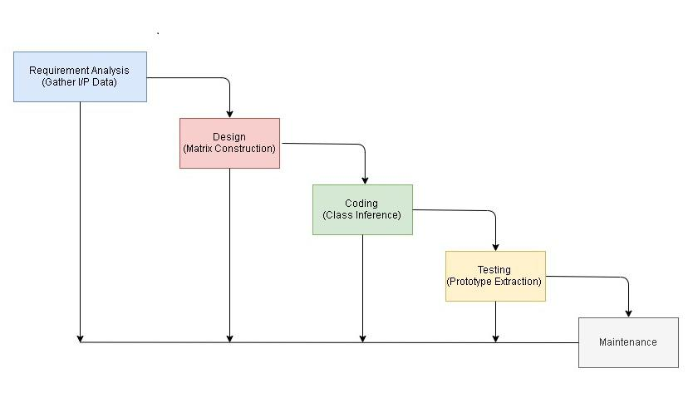

Figure 3.1: Waterfall Model

SDCL Waterfall model is being depicted by our system.

- The initial stage is requirement analysis stage here the data is being gathered which is to be provided as an input to the system.

- Second stage is the design stage where all the data is being formatted into a particular matrix. The scores are used to generate the matrix.

- Third stage is the coding stage in which the system performs its main functionality of mapping of the classes and getting the exact prototype.

- Testing is done in the fourth phase in order to test the image with the probabilistic label.

13

Department of Computer Engineering, AISSMS’s Institute of Information Technology, Pune. 2019-2020

AUTOMATIC TRAINING DATA GENERATION WITH AFFINITY CODING

- In the maintenance phase it’s the last phase wherein the system has to depict and maintain the probabilistic labels of the respective images.

3.7 System Implementation Plan

In the system plan implementation the input is the unlabeled dataset that comprises of images, text or the tabular data. This being then given to the Chanel of the CNN in order to produce the prototype of the image. This prototype is being then given to the system in order to generate the matrix and further the class inference. Output then generated are the probabilistic labels to the unlabeled images.

Table 3.1: System Implementation Plan

SR | DURATION | ACTIVITY PERFORMED
NO
1 | July second week | Topic Finalization
2 | 3rd and 4th week of July | Understanding of Base Paper
3 | 1st and 2nd week of August | Literature Survey
4 | 3rd and 4th week of August | System Architecture Design Completion
5 | 1stand 2nd week of September | 1st review Completed
6 | 3rd and 4th week of September | 2nd review Completed
7 | 1st week of October | UML diagrams, State Charts and DFD’s
 |  | Completed
8 | 2nd week of October | 3rd Review Completed
9 | 3rd and 4th week of October | Final review completed
10 | November | Exam
11 | December second week | Distribution of implementation modules
12 | January | Project implementation in modules
13 | February | Development of the entire module
14 | March | Testing of the project
15 | April rst week | Final Report Submission

14

Department of Computer Engineering, AISSMS’s Institute of Information Technology, Pune. 2019-2020

Chapter 4

SYSTEM DESIGN

4.1 System Architecture

A face recognition system is a computer application for automatically identifying or verifying a person from a digital image or a video frame from a video source. Features like face recognition and One-Time Password (OTP) are used for the enhancement of security of accounts and privacy of users. Face recognition technology helps the machine to identify each and every user uniquely. Fig 1 illustrates the system architecture of proposed system. It consists of a three-step secure authentication process for working employees in their respective organizations.
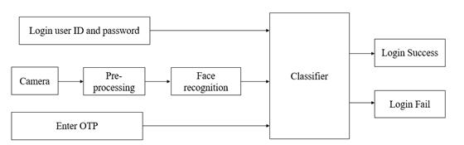

Figure 4.1: System Architecture of Proposed System

As stated above, at first the user needs to enter the unique login Id and password combination provided to them by the company. Once that matches with the database, next step is to generate the OTP on the registered mobile number. If not, further access to login into the system will be denied. If correct generated OTP is entered into the system, the user moves second step ahead to gain access to the system. Once this is done, next comes the face recognition. With the help of webcams present with

15

AUTOMATIC TRAINING DATA GENERATION WITH AFFINITY CODING

each and every system, the face in front of cam is detected. A live image is captured automatically through a webcam installed on the device, which is compared with the image stored in the database. If this image matches, user can get the access to operate that particular system. Haar Cascade Classifier is used to implement face recognition. An additional feature of auto saves and auto-logout is also included in this system. Suppose the employee happens to leave their desk due to some reasons, the webcam will be continuously detecting and capturing the images if any. Incase an un-known face image other than that system user, is captured by the webcam, the whole work/data will be automatically saved to the company’s server and the system will automatically logout, so that, the unknown user cannot make any manipulations in the users work. The auto save feature helps the user to re-continue the work form the point he/she had left it. Hence a very efficient, safe and reliable system is developed.

4.2 Data Flow Diagrams
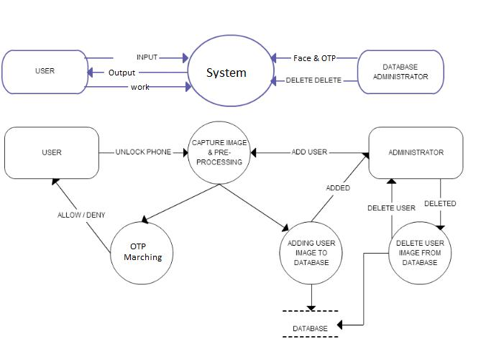

Figure 4.2: DFD Level

16

Department of Computer Engineering, AISSMS’s Institute of Information Technology, Pune. 2019-2020

AUTOMATIC TRAINING DATA GENERATION WITH AFFINITY CODING
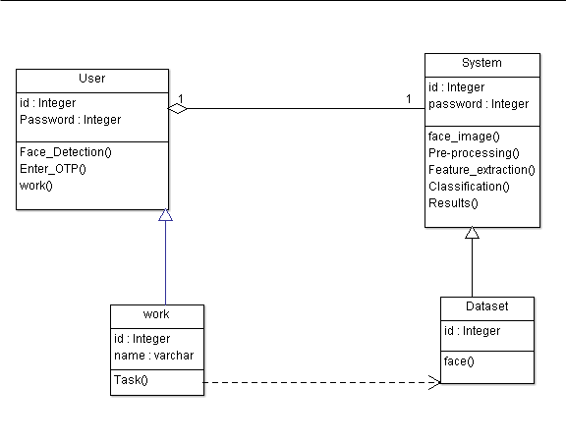

Figure 4.3: Class Diagram

4.3 UML Diagrams

Class Diagram

The class diagram is used for representing the entire system in the classes having attributes and functionalities.

- They include the entities as the classes.

- Class contains the attributes and the functions.

- User, System and Activity are the classes representing their different variables and functions used.

- The user uses the attributes like the image, text, tabular format data.

- The system uses the functionalities like matrix construction() and the construction of the class inference().

17

Department of Computer Engineering, AISSMS’s Institute of Information Technology, Pune. 2019-2020

AUTOMATIC TRAINING DATA GENERATION WITH AFFINITY CODING
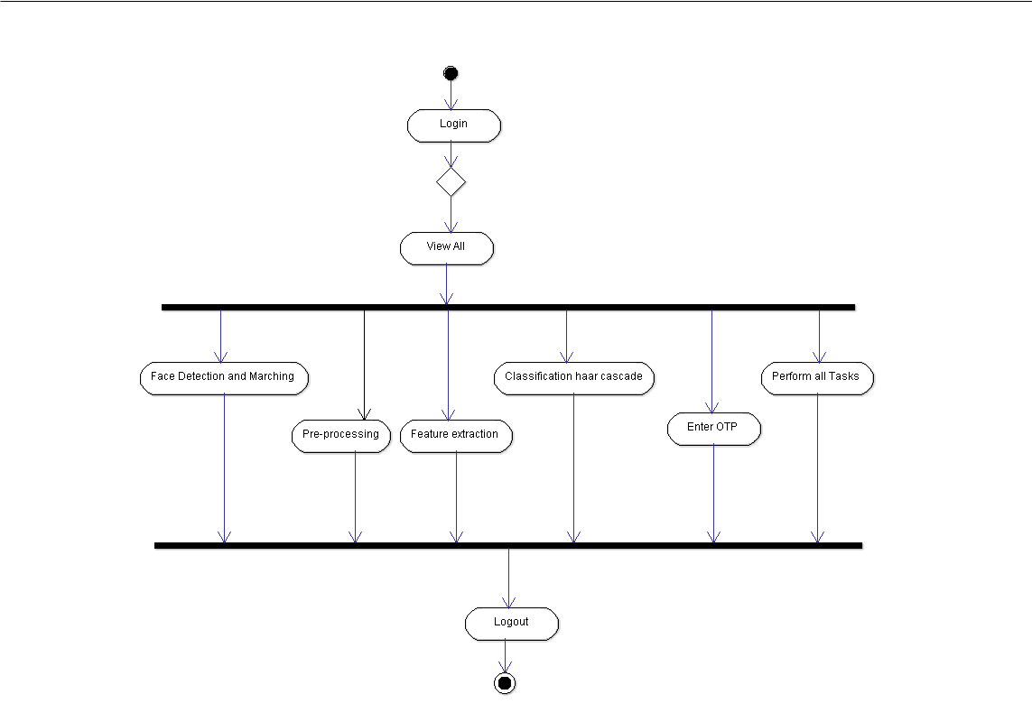

Figure 4.4: Activity Diagram

Activity Diagram

- Activity Diagram is a behavioral diagram presenting the actors their functions performed.

- They also include the swim lanes and the forks and joins.

- The represent the individual lane as their entire activities and the functionality carried out by that particular actor in the respective lanes.

- Input is being provided by the user and the output is being given back to the user.

18

Department of Computer Engineering, AISSMS’s Institute of Information Technology, Pune. 2019-2020

AUTOMATIC TRAINING DATA GENERATION WITH AFFINITY CODING

State Diagram
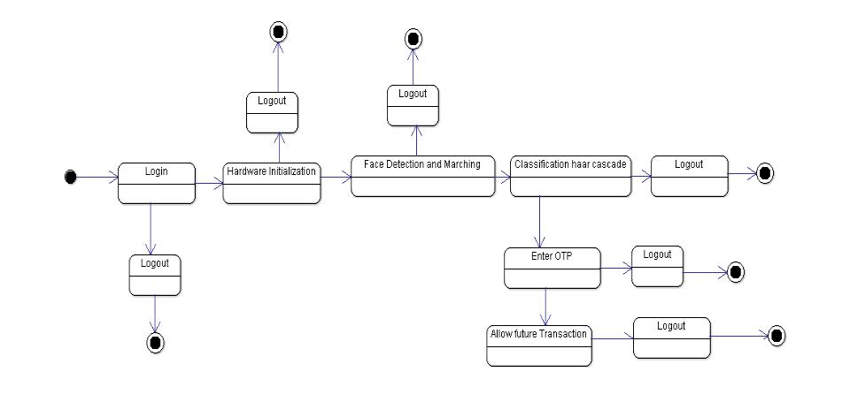

Figure 4.5: State Diagram

- Indicating the different states of the system along with inputs given conditions.

- Input is the unlabeled dataset to the initial state.

- Output of the system is the probabilistic label.

- The system is in the on state after the input data is given to the matrix construction phase.

- The input for every state is the output of the previous state

- The system is ideal only when the input data is accepted by the system after that the system is on state.

19

Department of Computer Engineering, AISSMS’s Institute of Information Technology, Pune. 2019-2020

AUTOMATIC TRAINING DATA GENERATION WITH AFFINITY CODING

Sequence Diagram
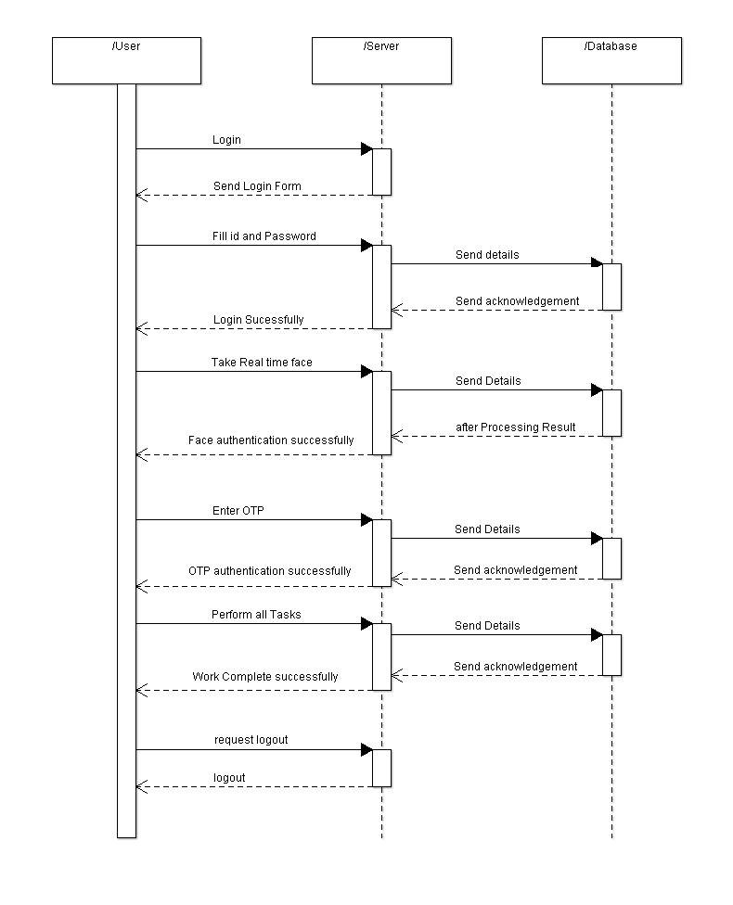

Figure 4.6: Sequence Diagram

- Actors

  - User

  - System

20

Department of Computer Engineering, AISSMS’s Institute of Information Technology, Pune. 2019-2020

AUTOMATIC TRAINING DATA GENERATION WITH AFFINITY CODING

  - Activity

- Different roles played by the different actors are been specified separately in their individual lanes.

- Each actor has number of timelines for the activity (Function) to be performed.

Use case Diagram
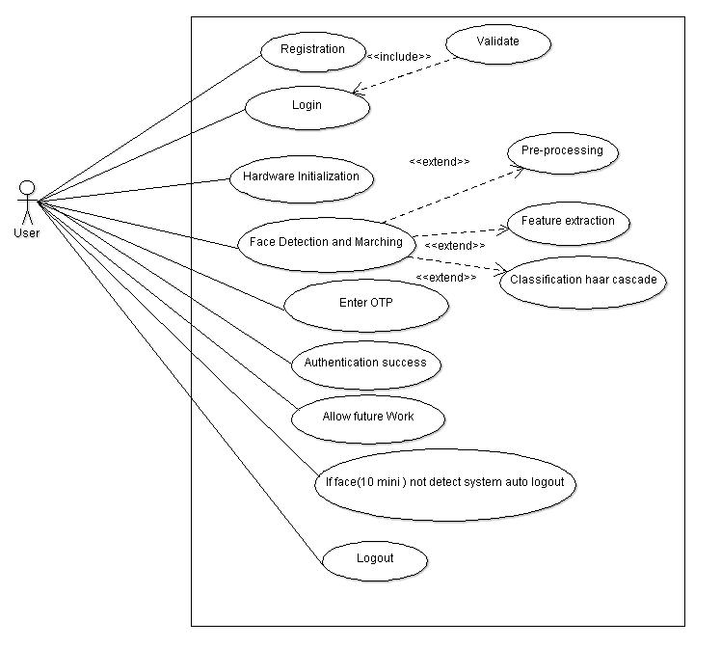

Figure 4.7: Use Case Diagram

Use Case diagram is used for representing the problem statement that is the actors in it, their functionality in an behavioral manner. They are useful when the system is to be in the programmatic execution.

21

Department of Computer Engineering, AISSMS’s Institute of Information Technology, Pune. 2019-2020

Chapter 5

OTHER SPECIFICATION

5.1 Advantages

- The proposed approach provides more control over the data that stored in the system and restricting the access to specific user for specific le with less privilege and for less time period on the basis of secret key using symmetric as well as asymmetric mechanism.

- The integrity and con denasality of data is guaranteed twice by providing encrypting using secret key but also to the access permission and limited le information.

- This system makes it more difficult to get illegal access to restricted resources.

5.2 Limitations

- If face is manipulated a bit (e.g. cover up the eyes with sunglasses, or tilt the head to a side), a Haar-based classifier may not be able to recognize the face.

- Manual intervention is required for training the model.

5.3 Applications

- Can be used in security sector.

- It can be used for securing IoT based smart services like smart home, smart grid etc.

22

Chapter 6

CONCLUSIONS AND FUTURE WORK

6.1 Conclusion

There has been a use of three tier architecture for providing the authentication and security to the system. Those tiers are login credentials, face recognition and OTP. All these tiers give a great strength for not only providing the authentication but also secure the data in the system. The proposed approach provides more control over the data that stored in the system and restricting the access to specific user for specifically with less privilege and for less time period on the basis of secret key using symmetric as well as asymmetric mechanism. The integrity and confidentiality of data is guaranteed twice by providing encrypting using secret key but also to the access permission and limited le information. Especially, the purpose of the one-time password is to make it more di cult to get illegal access to restricted resources.

6.2 Future work

- In order to overcome the drawbacks of proposed system if anyone tries to hack the data, the authorized user will get a notification and through an email or message and the authorized user can crash the hard disk. In order to recover it back through particular system software might be needed.

- There can also be changes in the phases of the tool and use anything else as per the convenience of the user. Our system will be compatible with many other types of scanners as well as sensors.

- The same system can be developed in such a way that it can run on multiple operating systems. For now the system used is windows, later it can even be

23

AUTOMATIC TRAINING DATA GENERATION WITH AFFINITY CODING

made compatible with mac as well as Linux for user’s convenience.

24

Department of Computer Engineering, AISSMS’s Institute of Information Technology, Pune. 2019-2020

ANNEXURE A

The system would perform the following satis ability tests to detect the following as NP Hard or NP Complete.

- When the input data is being fed to the system the entire data must be fed to the system be it of the small size or medium size data. It is an NP Complete problem.

- Image to be compared is available in the training dataset. It is an NP Hard problem because the image is sometimes not exactly available in the dataset.

- The construction of the matrix is an NP Complete problem.

- Construction of the class inference is an NP Complete problem.

- Possibility of finding the exact prototype of the image is and NP Complete problem because even if the exact match is not found at least the best prototype is being matched.

- Assignment of the appropriate probabilistic label is an NP Complete problem.

25

ANNEXURE B

- Joulin et.al in 2018 proposed a system using deep learning where the \unsu-pervised learning" of visual features is being predicted.

- Das Sarma et.la in the year 2016 in an international conference proposed a system towards globally optimizing the large amount of data.

- Davis in their manual proposal of 88000 articles proposed a system explaining the text mining for a drug-disease in the year 2013, using a drug database along.

- Ratner in the year 2016 proposed a system \Snorkel" for the automatic generation of training data. In this they summarized the matrix construction and labelling function for the automation of system.

26

ANNEXURE C: PLAGIARISM

27

Bibliography

- Patil, A., Rana, D., Vichare, S., Raut, C. (2018). E ective Authentication for Restricing Unauthorized User. 2018 International Conference on Smart City and Emerging Technology (ICSCET). doi:10.1109/icscet.2018.8537323

- IEEE INTERNET OF THINGS JOURNAL 1 Sensor-based Continuous Authen-tication of Smartphones’ Users Using Behavioral Biometrics: A Contemporary Survey Mohammed Abuhamad, Ahmed Abusnaina, DaeHun Nyang, and David Mohaisen arXiv:2001.08578v2 [cs.CR] 10 May 2020

- A Multimodal Biometric User Veri cation System with Identical Twin using SVM 2 B.Lakshmi priya, M.Pushpa Rani International Journal of Recent Tech-nology and Engineering (IJRTE) ISSN: 2277-3878, Volume-8 Issue-6, March 2020

- Multi-Biometric Authentication Using Deep Learning Classi er for Securing of Healthcare Data Dr. Gandhimathi Amirthalingam1 , Harrin Thangavel Volume 8, No.4, July { August 2019 International Journal of Advanced Trends in Com-puter Science and Engineering

- Cloud security: to prevent unauthorized access using an e cient key manage-ment authentication algorithm S. Naveen Kumar1*, K. Nirmala2 International Journal of Engineering Technology, 7 (1.1) (2018) 607-611 International Journal of Engineering Technology

- On keystrokes as Continuous User Biometric Authentication Suhail Javed Quraishi, Sarabjeet Singh Bedi International Journal of Engineering and Ad-vanced Technology (IJEAT) ISSN: 2249 { 8958, Volume-8 Issue-6, August 2019

- A Robust e-Invigilation System Employing Multimodal Biometric Authentica-tion Salam S. Ketab, Nathan L. Clarke, and Paul S. Dowland International

28

AUTOMATIC TRAINING DATA GENERATION WITH AFFINITY CODING

Journal of Information and Education Technology, Vol. 7, No. 11, November 2017

- EFFECTIVE AUTHENTICATION FOR AVOIDING UNAUTHORIZED USER ACCESS Ms. Chaitali A.Raut International Journal of Recent Trends in Engineering Research (IJRTER) Volume 04, Issue 07; July - 2018 [ISSN: 2455-1457]

- INTERNATIONAL JOURNAL OF SCIENTIFIC TECHNOLOGY RE-

SEARCH VOLUME 7, ISSUE 11, NOVEMBER 2018 ISSN 2277-8616 182 IJSTR©2018 www.ijstr.org Modified Role Based Access Control Model For Data Security Bukohwo Michael Esiefarienrhe, Abubakar Hashimu Ekka

- Gurudatt Kulkarni, Ruchira Chandorkar, Nikita Chavan, "A SECURITY BY BIOMETRIC AUTHENTICATION" International Journal of Computer Sci-ence and Engineering Research and Development (IJCSERD), ISSN 2248- 9363 (Print), ISSN 2248-9371 (Online) Volume 2, Number 1, July-December (2012)

29

Department of Computer Engineering, AISSMS’s Institute of Information Technology, Pune. 2019-2020

